PROJECT DEMONSTRATION
IMPORT DATA USING TRANSFORM MAPS (SPREADSHEET)

Details | Information
Project Title | Import Data Using Transform Maps (Spreadsheet) in ServiceNow
Team ID | SWTID-2026-1408
Team Size | 4
Team Leader | SWETHA R
Team Member | AJITHA A
Team Member | AFREEN BENASIR M
Team Member | RIHANA M

1. Introduction

1.1 Project Description
This micro project focuses on importing structured employee data from an external spreadsheet into the ServiceNow platform using Import Sets and Transform Maps. The project simulates a real-world scenario in which bulk employee data is received in Excel format and migrated into ServiceNow efficiently and accurately.
The spreadsheet data is first loaded into an Import Set table, which acts as a staging area. A Transform Map is then configured to map source fields to the appropriate fields in the Employee Test table. Coalesce is used to identify existing employee records and prevent duplicate records during repeated imports. New employee records are inserted, while existing records can be updated when their information changes. Reports and a dashboard are created to provide meaningful insights into the employee data.

1.2 Project Objectives
- Understand the ServiceNow data import process.
- Import employee data from a spreadsheet.
- Create a custom Employee Test table.
- Create and use an Import Set table.
- Configure and use a Transform Map.
- Map source fields to target fields.
- Use Coalesce to prevent duplicate employee records.
- Validate imported and transformed records.
- Create reports and a dashboard for employee data.

2. Project Overview

2.1 Purpose
The purpose of this project is to provide an efficient method for importing and managing bulk employee information in ServiceNow. Instead of entering employee records manually, the data can be prepared in a spreadsheet and imported using Import Sets and Transform Maps.
Overall Process:
Excel Spreadsheet → Load Data → Import Set Table → Transform Map → Field Mapping → Coalesce → Employee Test Table → Reports → Dashboard

2.2 Key Features
- Import employee data from Excel.
- Create a custom Employee Test table.
- Create an Import Set table.
- Configure a Transform Map.
- Automatically map matching fields.
- Manually map fields using Mapping Assist.
- Transform imported records.
- Validate imported records.
- Prevent duplicates using Coalesce.
- Create reports and a dashboard.

2.3 Project Workflow
Prepare Spreadsheet → Create Employee Test Table → Load Spreadsheet Data → Create Import Set → Create Transform Map → Map Source and Target Fields → Transform Data → Validate Records → Enable Coalesce → Import Updated/New Data → Verify Insert/Update/Ignore → Create Reports → Create Dashboard

3. Architecture
This project is developed completely within ServiceNow and does not require a traditional React frontend, Node.js backend, or MongoDB database architecture. It follows the ServiceNow Import Set and Transform Map architecture.

3.1 System Architecture
External Data Source: Excel Spreadsheet
↓
Load Data
↓
Import Set Table: u_employee_import
↓
Transform Map: Sample Spreadsheet Import
↓
Field Mapping + Coalesce
↓
Employee Test Table: u_employee_test
↓
Reports + Dashboard

3.2 Spreadsheet
The spreadsheet is the external source of employee data. The sample file is named Sample Spreadsheet.xlsx.
Employee ID | Employee Name | Email | Department | Location
sbc001 | user1 | user1@gmail.com | servicenow | tamilnadu
sbc002 | user2 | user2@gmail.com | servicenow | tamilnadu
sbc003 | user3 | user3@gmail.com | servicenow | tamilnadu
sbc004 | user4 | user4@gmail.com | servicenow | tamilnadu
sbc005 | user5 | user5@gmail.com | salesforce | tamilnadu

3.3 Import Set
The Import Set provides a temporary staging area for spreadsheet data. The imported data is stored in the Employee Import table with backend name u_employee_import.

3.4 Transform Map
The Transform Map controls the movement of data from the Import Set table to the target table.
Property | Value
Transform Map | Sample Spreadsheet Import
Source | Employee Import
Target | Employee Test

3.5 Target Table
The final employee information is stored in the Employee Test table with backend name u_employee_test.
- Employee ID
- Employee Name
- Email
- Department
- Location

3.6 Coalesce
Employee ID is used as the identifying field. If the Employee ID exists, the existing record is updated; if it does not exist, a new record is inserted.

4. Setup Instructions

4.1 Prerequisites
- ServiceNow instance.
- Valid ServiceNow credentials.
- Appropriate ServiceNow permissions.
- Google Sheets or Microsoft Excel.
- Employee sample data.
- Basic knowledge of ServiceNow tables, Import Sets, and Transform Maps.

4.2 Phase 1 – Prepare the Spreadsheet
- Open Google Sheets or Microsoft Excel.
- Create a new spreadsheet.
- Enter the employee data with the required headings: Employee ID, Employee Name, Email, Department and Location.
- Download the spreadsheet as Sample Spreadsheet.xlsx.

5. Create Custom Employee Table

5.1 Navigation
All → Tables → Create New

5.2 Table Details
Property | Value
Label | Employee Test
Name | u_employee_test
Save the table.

5.3 Create Employee Fields
After saving the table, open the form and use Configure → Form Layout. Create the following fields:
Column Label | Type
Employee ID | String
Employee Name | String
Email | String
Department | String
Location | String
Save and verify that all fields appear on the Employee Test form.

6. Create Import Set Table

6.1 Navigation
All → System Import Sets → Load Data

6.2 Import Details
Upload the prepared Excel spreadsheet. Create or select the Import Set table.
Property | Value
Label | Employee Import
Name | u_employee_import
Click Submit. After the import is completed, select Create Transform Map.

7. Create Transform Map

7.1 Transform Map Details
Property | Value
Name | Sample Spreadsheet Import
Source Table | Employee Import
Target Table | Employee Test

7.2 Auto Map Matching Fields
Click Auto Map Matching Fields. ServiceNow automatically maps source and target fields with matching names.

7.3 Mapping Assist
Use Mapping Assist to verify or manually create the following field mappings:
Source Field | Target Field
Employee ID | Employee ID
Employee Name | Employee Name
Email | Email
Department | Department
Location | Location

7.4 Transform the Data
- Select the required Import Set and Transform Map.
- Click Transform.
- Allow ServiceNow to process the imported records.
- Verify the successful transformation message.
- Open the Employee Test table and verify the records.

8. Running the Application / Project
Unlike a React or Node.js application, this ServiceNow project does not require commands such as npm start. The project runs directly inside the ServiceNow instance.
Execution Process:
Login to ServiceNow → Open Load Data → Upload Spreadsheet → Create/Select Import Set → Create Transform Map → Map Fields → Run Transform → Verify Employee Test Table

9. Data Transformation and Validation
After transformation, open the Employee Test table through the Application Navigator. The imported employee records should be displayed.

Expected Result
All valid spreadsheet records should be successfully created in the Employee Test table, with the corresponding Employee ID, Employee Name, Email, Department and Location values.

10. Authentication and Authorization
The project uses ServiceNow's built-in authentication and authorization mechanism. Users must log in with valid credentials. Access to tables, Import Sets, Transform Maps, Reports and Dashboards depends on assigned roles and permissions.
- Upload data.
- Create Import Sets.
- Create Transform Maps.
- Modify employee records.
- Create reports.
- View dashboards.
- Share dashboards.
No custom JWT or token-based authentication is required because the project operates within the ServiceNow platform.

11. Coalesce and Duplicate Prevention

11.1 Purpose
When the same employee spreadsheet is imported multiple times, duplicate records can be created if there is no duplicate-handling mechanism. Coalesce solves this problem by using a unique identifying field.

11.2 Configuration
Open Sample Spreadsheet Import → Field Maps → Employee ID → Set Coalesce = True → Save the Transform Map.

11.3 Coalesce Logic
Employee ID exists? → Yes: Update existing record. → No: Insert new record.
This allows the system to distinguish between new and existing employees during repeated imports.

12. Testing Insert, Update and Ignore Operations

12.1 Load the New Spreadsheet
- Navigate to All → System Import Sets → Load Data.
- Select Existing Table → Employee Import.
- Choose the new Excel file.
- Set Sheet Number = 1 and Header Row = 1.
- Click Submit.

12.2 Run Transform
Select Run Transform, choose the existing Transform Map and click Transform. After completion, open Transform History.

12.3 Expected Result
Operation | Records
Inserted | 2
Updated | 2
Ignored | 0
Total | 4
The two new Employee IDs are inserted and the two existing Employee IDs are updated.

12.4 Re-import the Same File
Upload the exact same spreadsheet again using the same Import Set and Transform Map.
Operation | Records
Inserted | 0
Updated | 0
Ignored | 4
Total | 4
This demonstrates duplicate prevention for repeated imports.

13. User Interface
- Spreadsheet – Contains the employee data to be imported.
- Employee Test Table – Displays final employee records.
- Load Data Page – Used to upload the Excel spreadsheet.
- Transform Map – Configures source, target and transformation.
- Field Mapping – Displays source-to-target field relationships.
- Transform History – Displays inserted, updated, ignored and failed records.
- Reports – Provides graphical and list-based views.
- Dashboard – Displays multiple reports in one centralized interface.

14. Reports and Analytics

14.1 Employees by Department
Property | Value
Report Name | Employees by Department
Source Type | Table
Table | Employee Test
Type | Pie Chart
Group By | Department
Aggregation | Count
The report displays the number of employees belonging to each department.

14.2 Employees by Location
Property | Value
Report Name | Employees by Location
Table | Employee Test
Type | Bar Chart
Group By | Location
Aggregation | Count
The report displays employee distribution based on location.

14.3 Employee List Report
Property | Value
Report Name | Employee List Report
Table | Employee Test
Type | List
Columns | Employee ID, Employee Name, Email, Department, Location
This report displays complete employee information in list format.

15. Dashboard

15.1 Create Dashboard
Navigation: All → Dashboards → Self Service → Dashboards
Property | Value
Dashboard Name | Employee Analytics Dashboard
Save the dashboard.

15.2 Add Reports to Dashboard
- Open the required report.
- Select Share → Add to Dashboards.
- Select Employee Analytics Dashboard.
- Click Add.
- Repeat for Employees by Location and Employee List Report.
The three reports are displayed together on the Employee Analytics Dashboard. Dashboard sharing options can be used according to appropriate access permissions.

16. Testing Strategy
Testing is performed at each major stage of the project.
Test Case | Input | Expected Result
Spreadsheet Upload | Valid Excel file | Data loads successfully
Import Set | Employee records | Records appear in Import Set
Field Mapping | Source and target fields | Correct mapping
Initial Transform | New records | Records inserted
Existing Employee | Existing Employee ID | Record updated
New Employee | New Employee ID | Record inserted
Duplicate Import | Same spreadsheet | Duplicate records prevented
Transform History | Completed transformation | Insert/update/ignore status displayed
Department Report | Employee Test data | Department-wise count displayed
Location Report | Employee Test data | Location-wise count displayed
Employee List | Employee Test data | Employee records displayed
Dashboard | Three reports | Reports displayed together

Validation
- Imported record count.
- Field values.
- Employee IDs.
- Updated records.
- Newly inserted records.
- Ignored records.
- Transform status.
- Report results.
- Dashboard display.

17. Screenshots / Demo

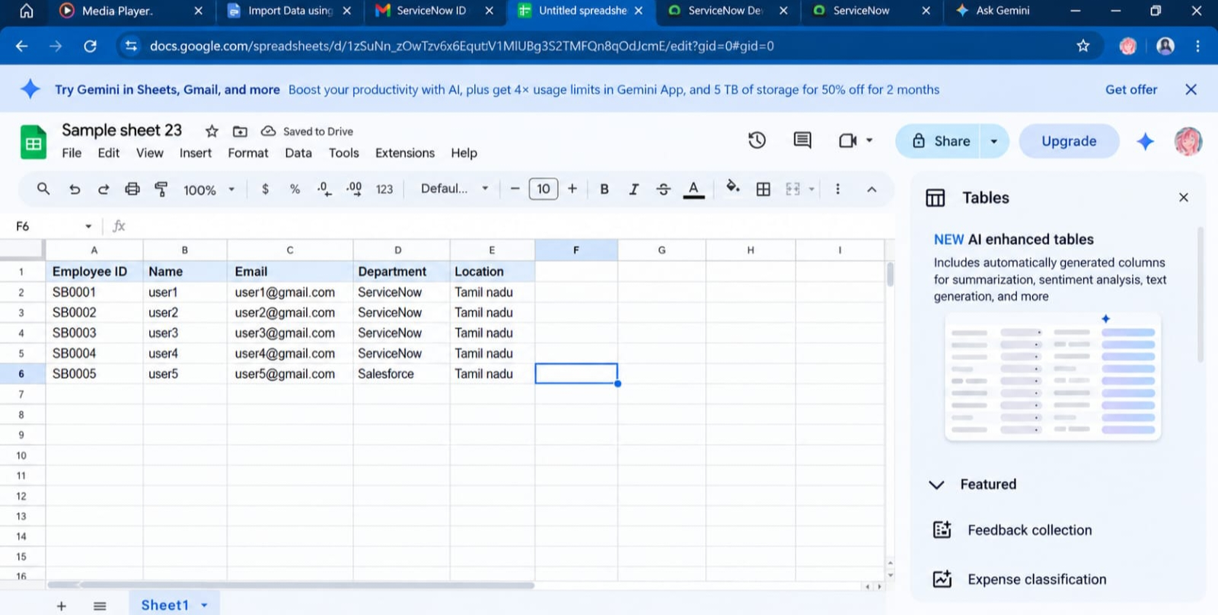
29. Sample Spreadsheet

30. Employee Test table creation
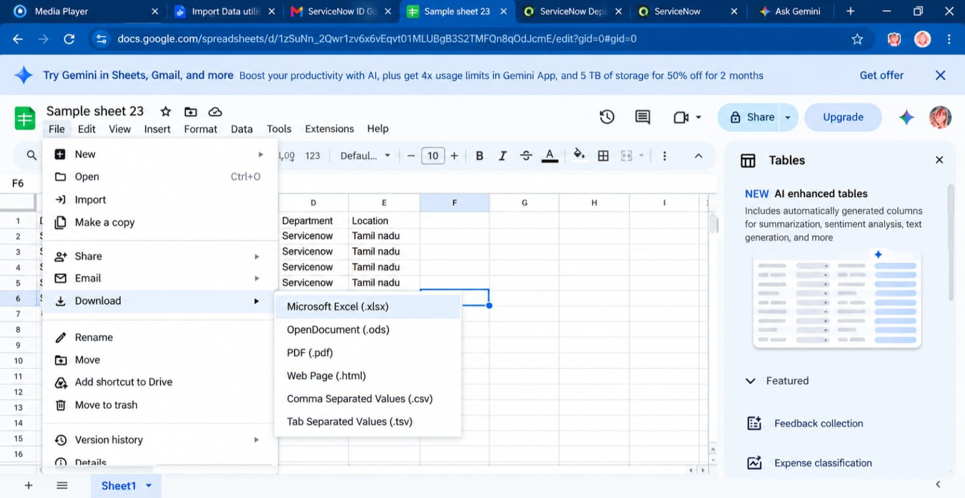

31. Employee Test fields

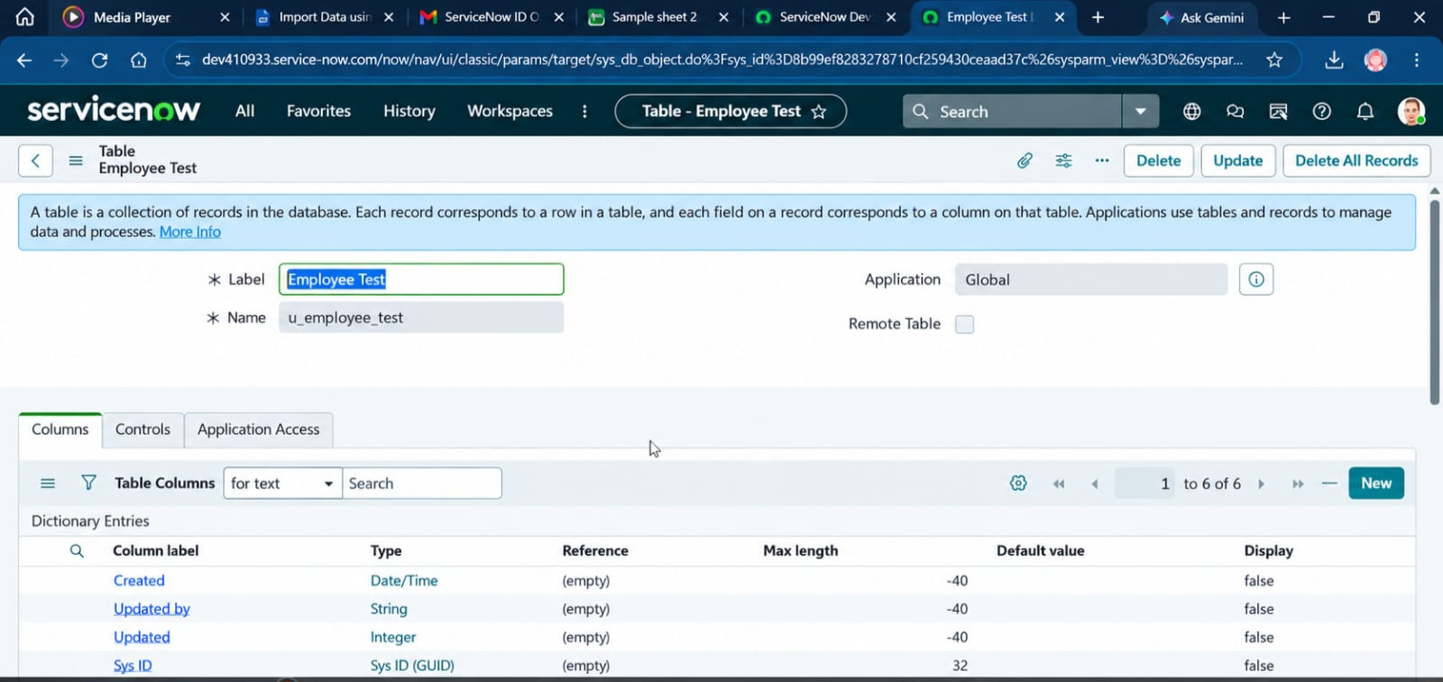

- Load Data page

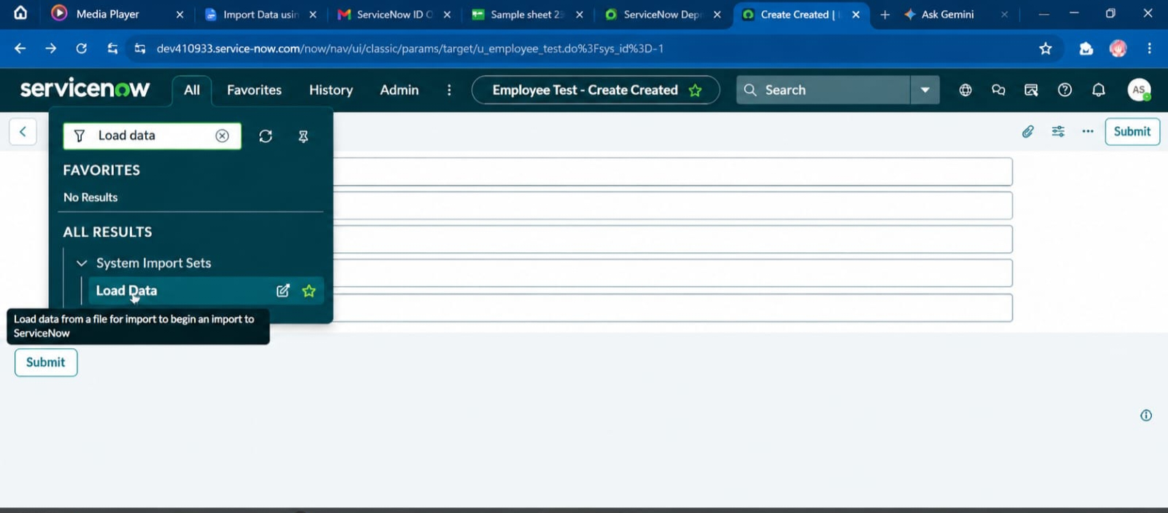

Employee Import table

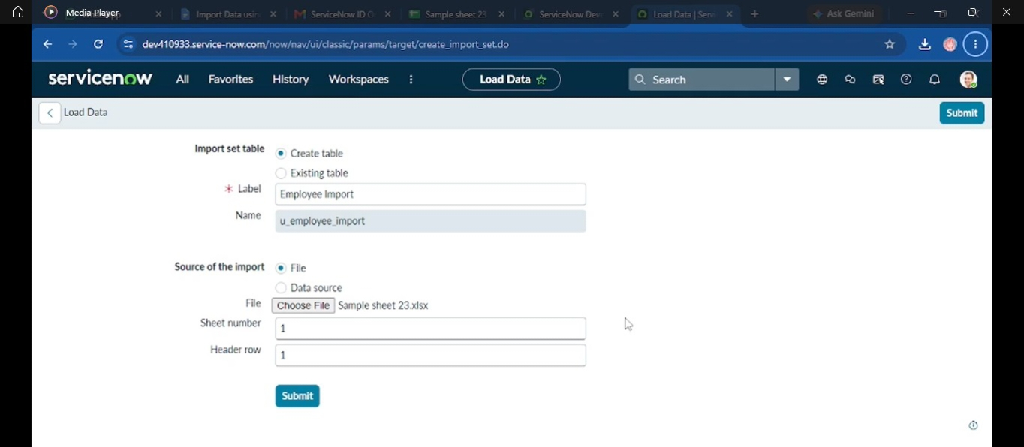

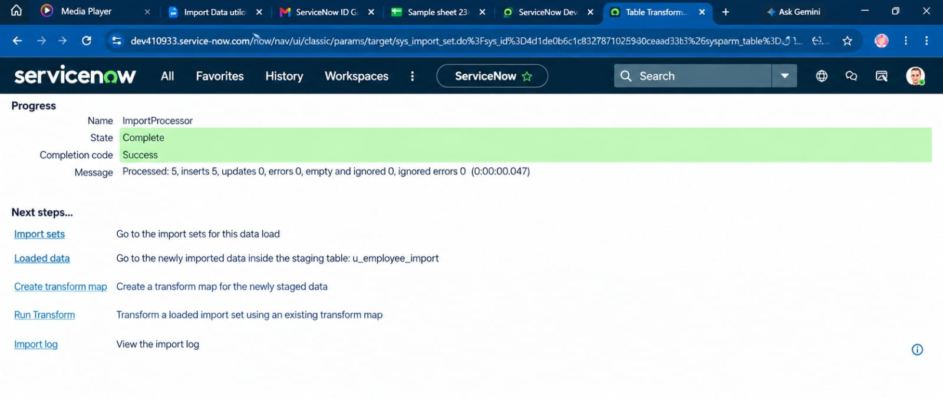

- Transform Map configuration

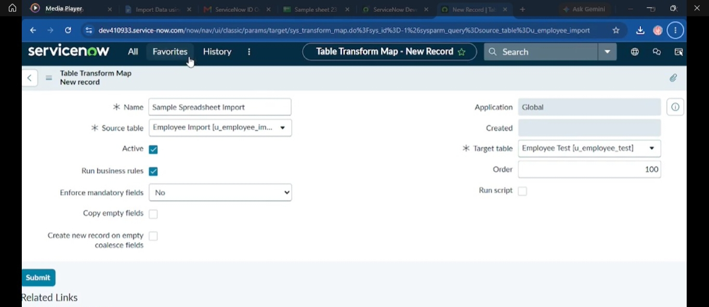

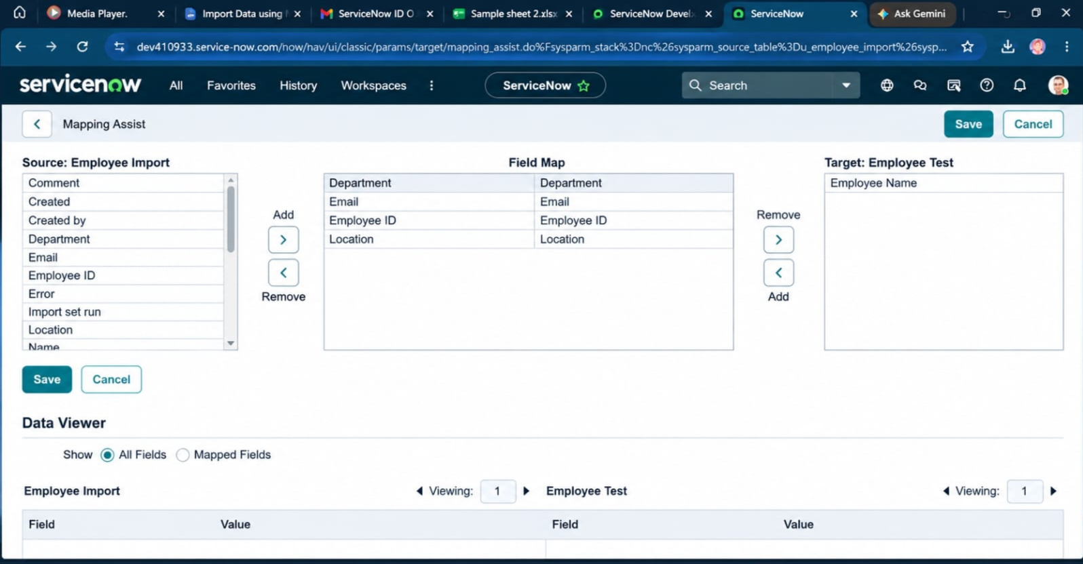

- Field Mapping

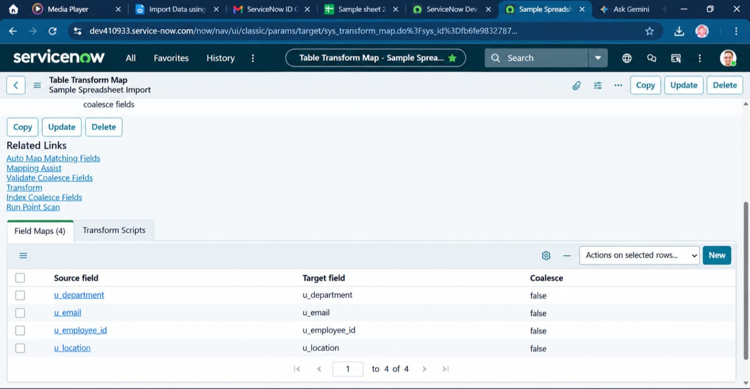

- Successful Transform

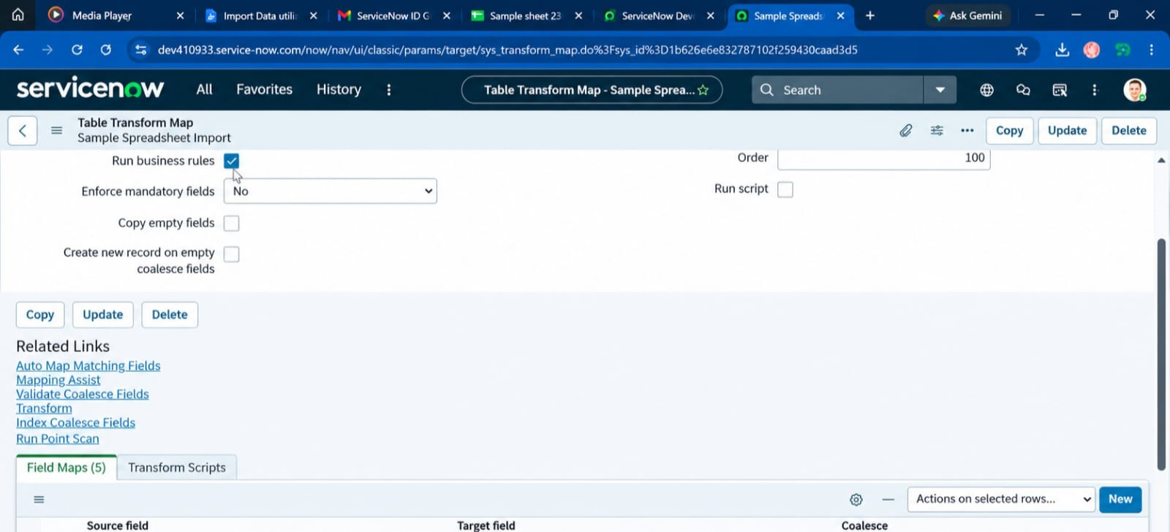

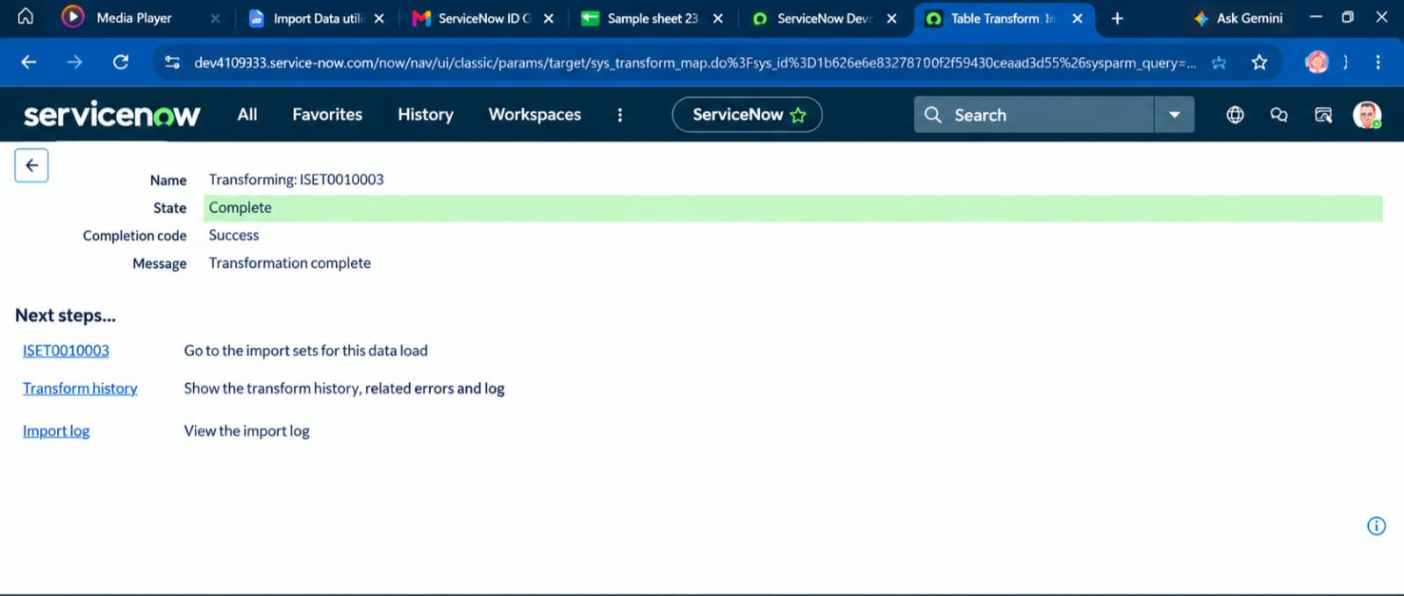
- Employee Test records

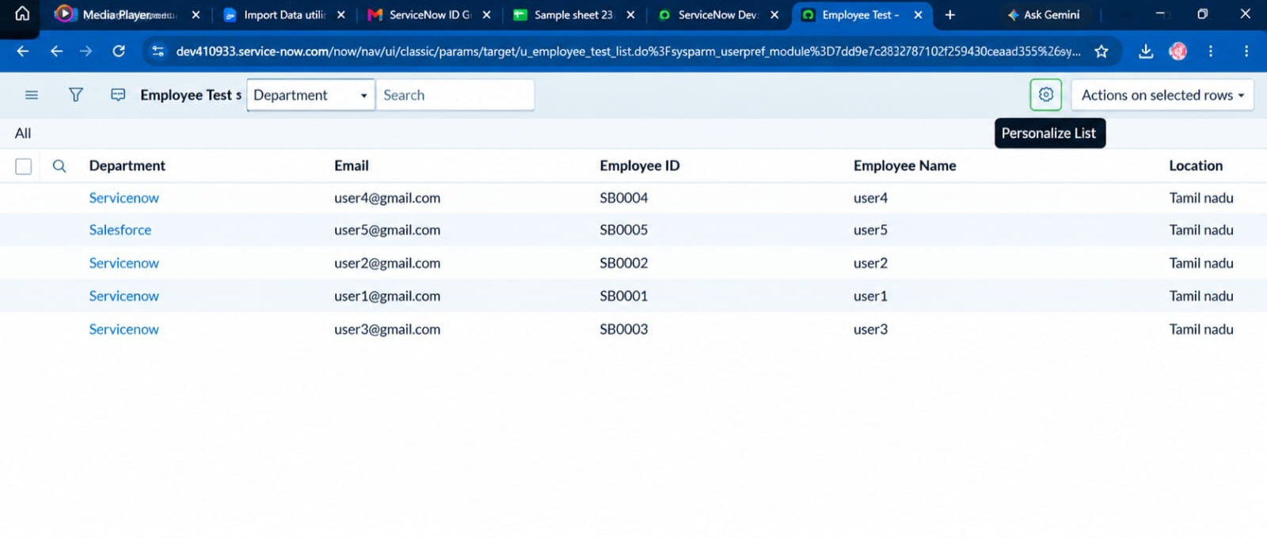

- Coalesce configuration

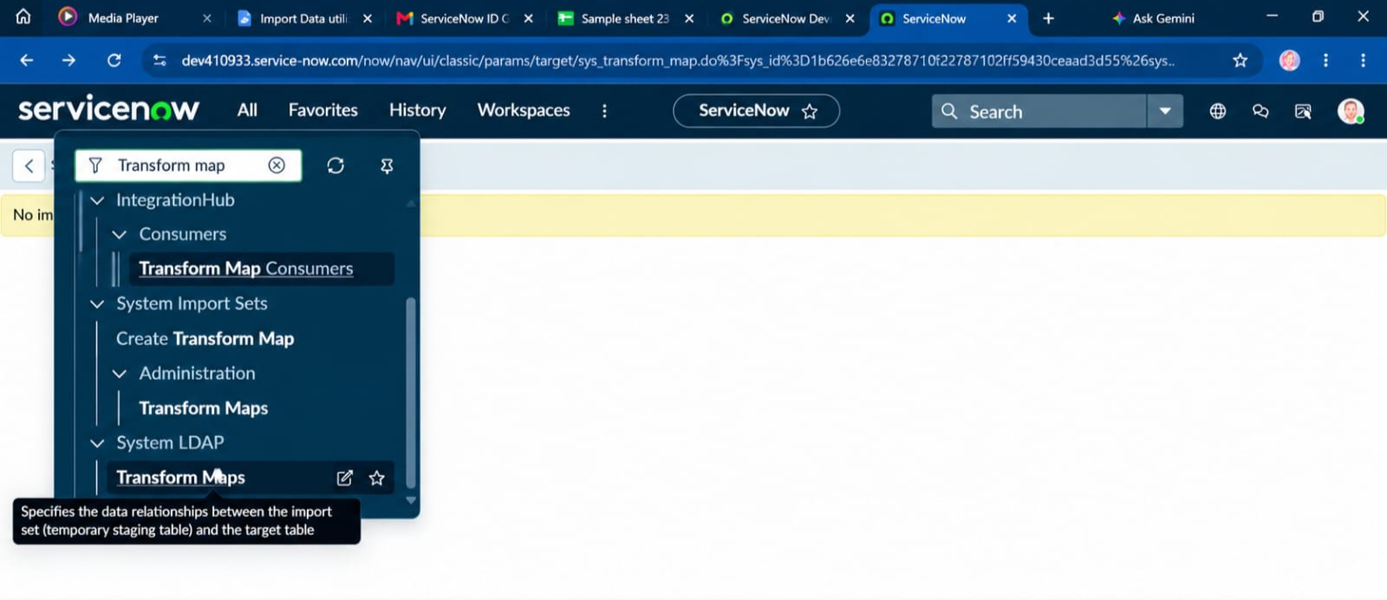

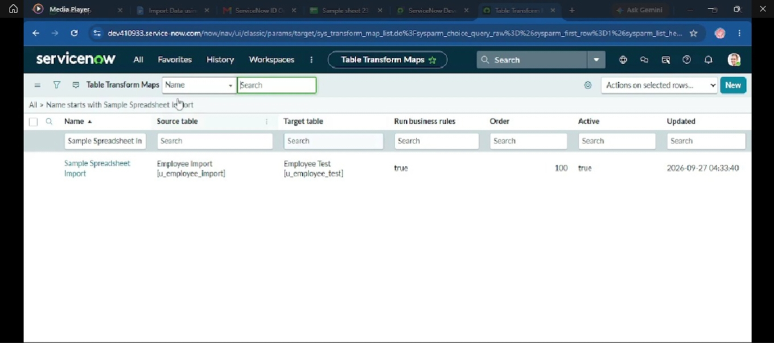

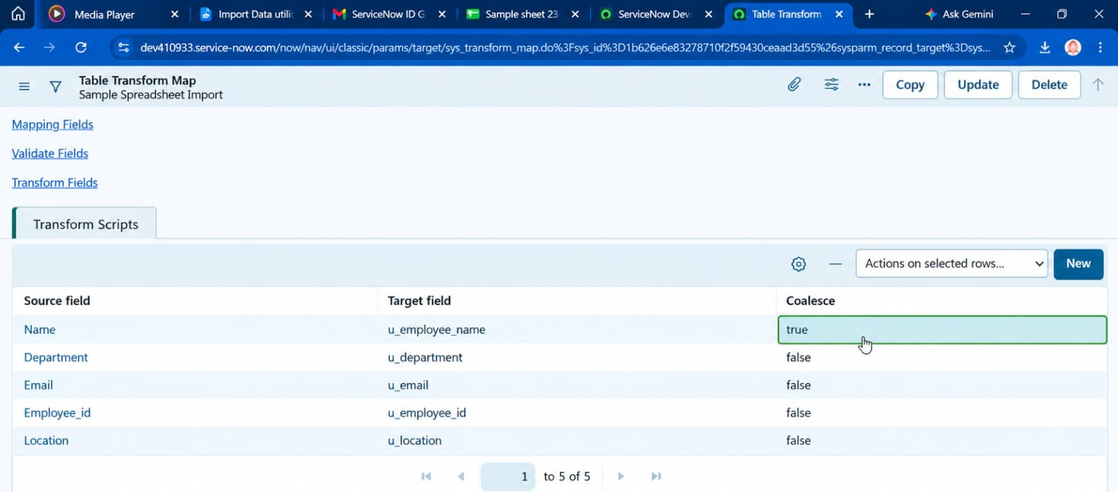

- New Excel data

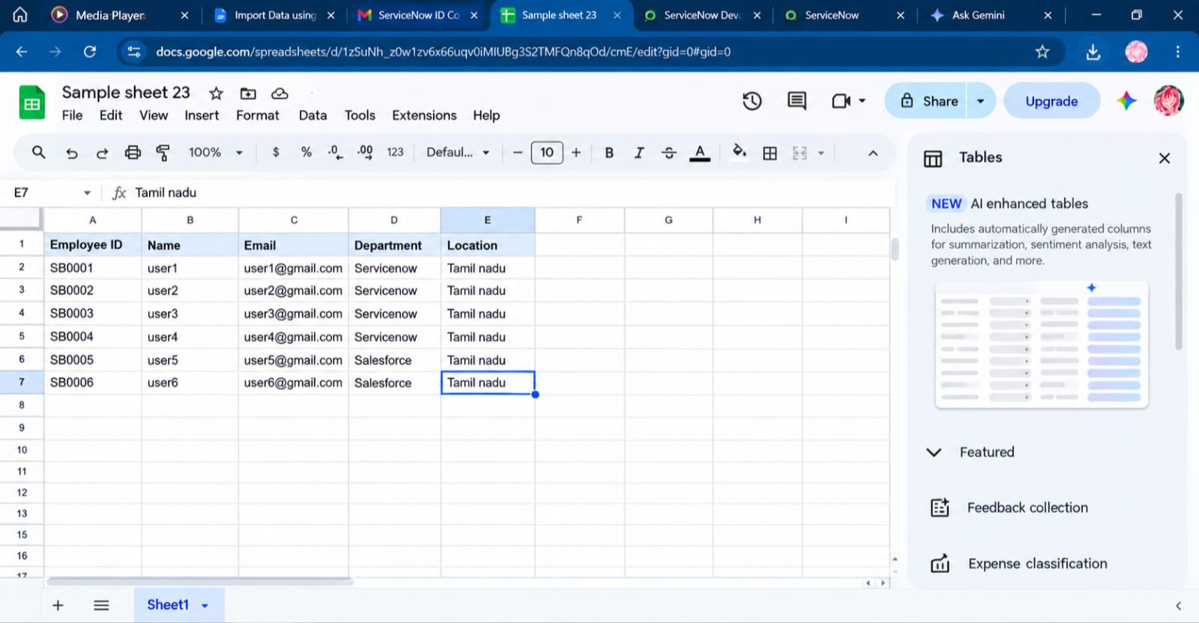

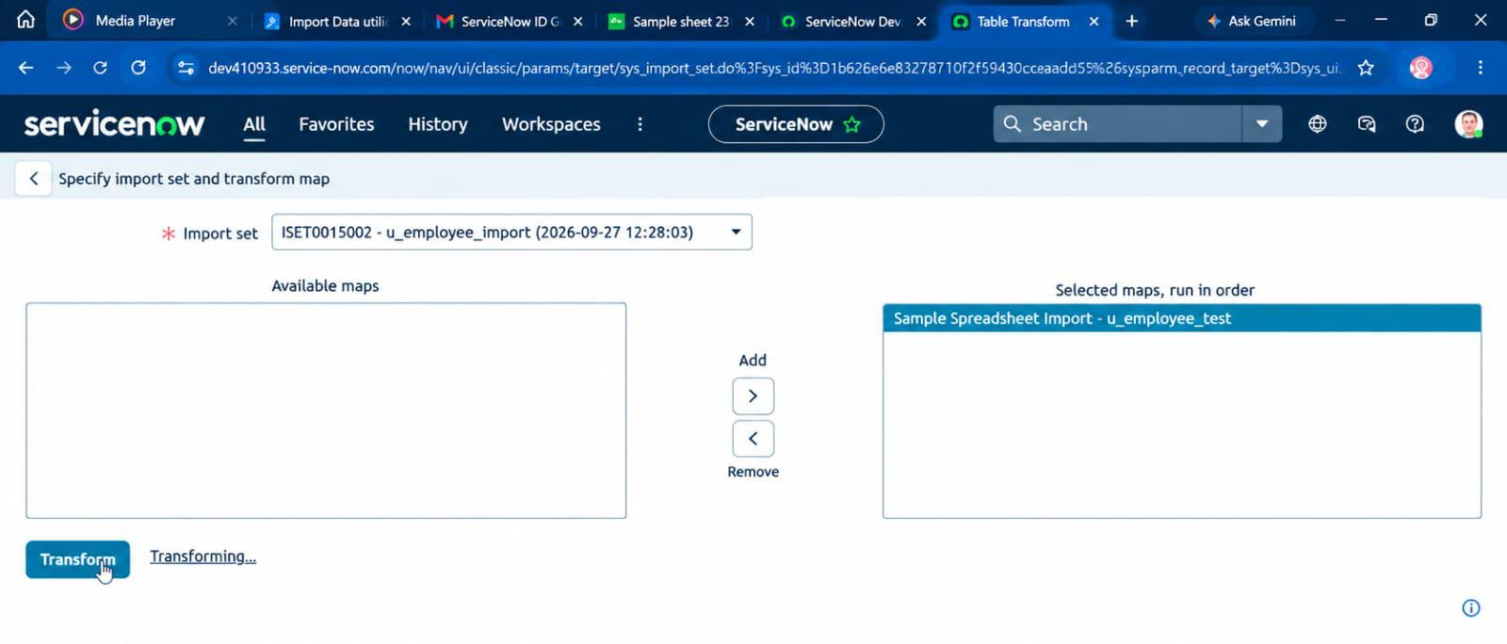

Transform History

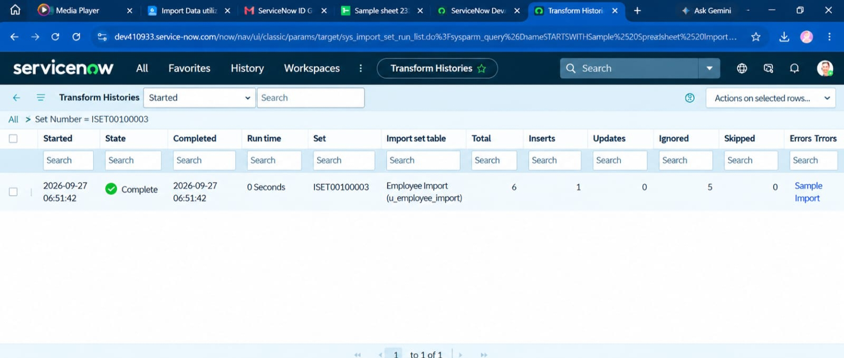
- Employees by Department report

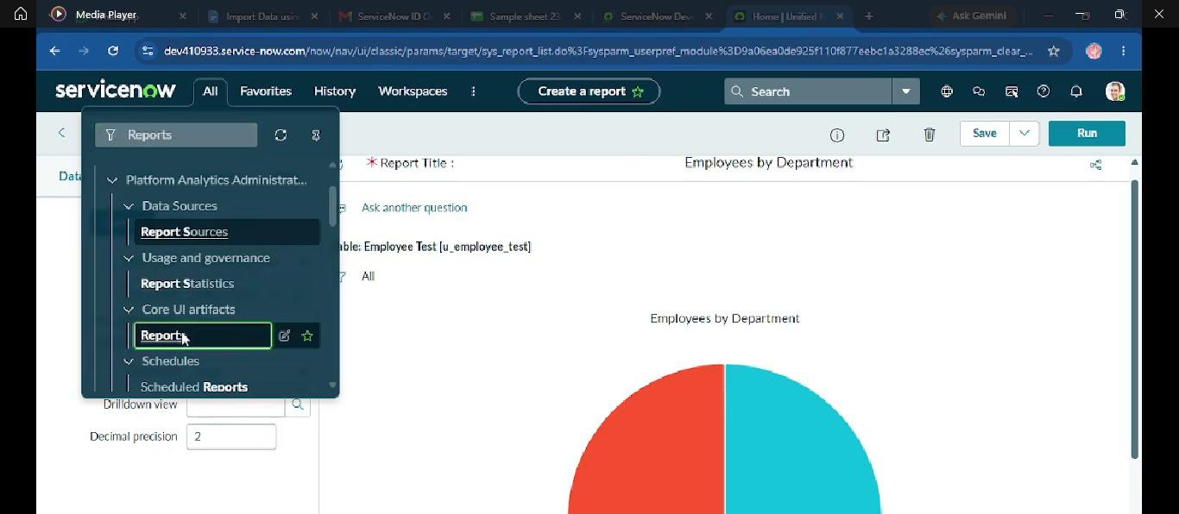

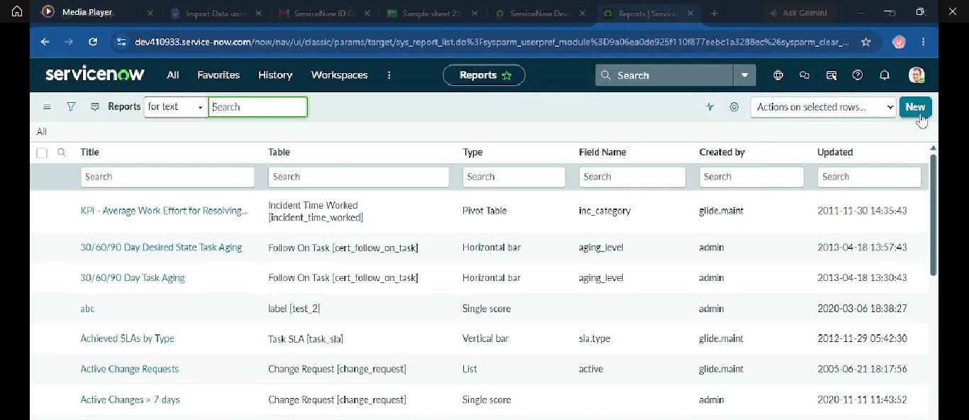
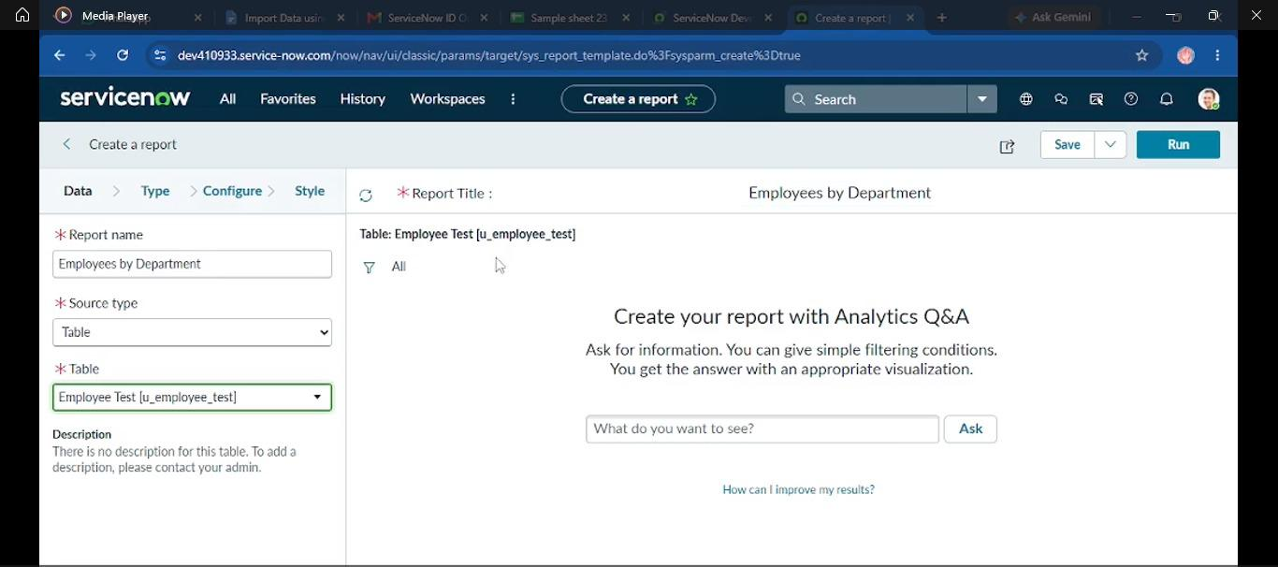

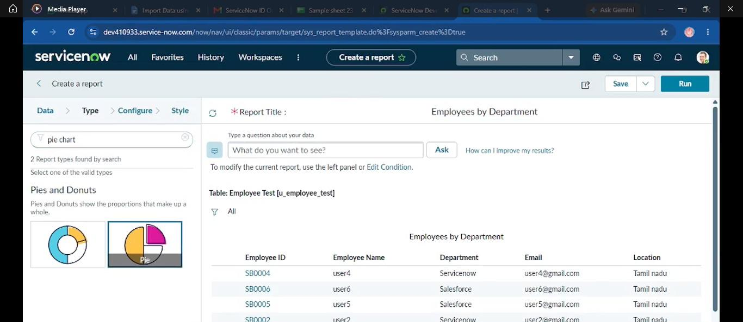

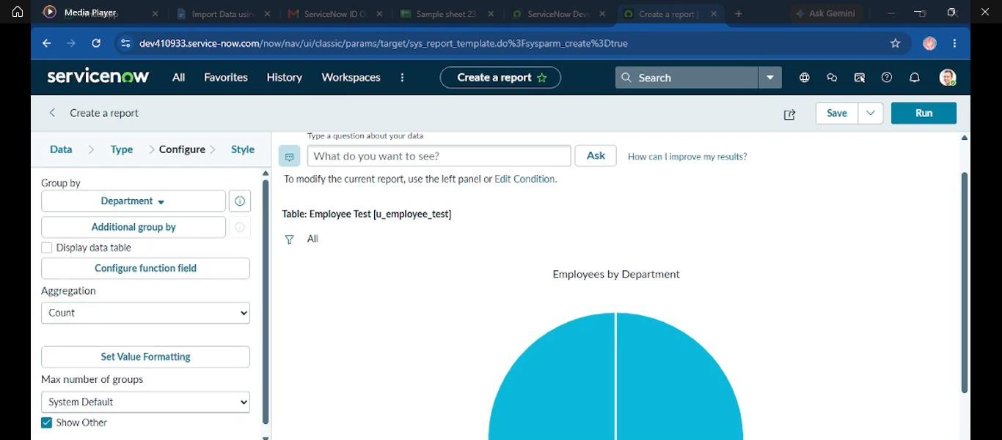

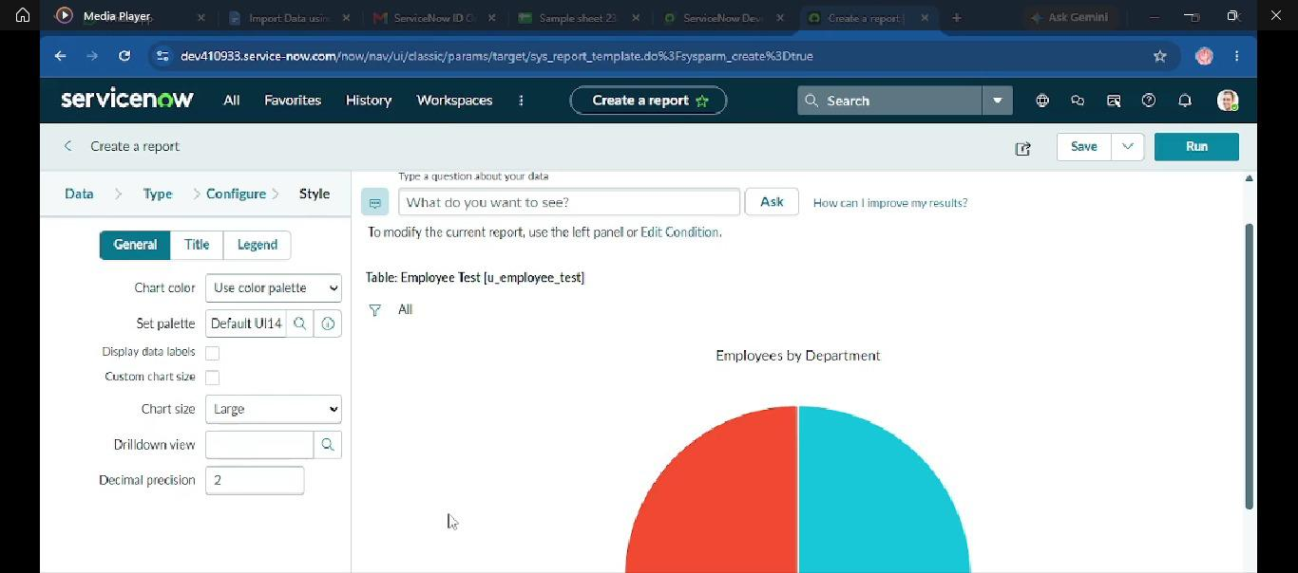

- Employees by Location report

- Employee List Report

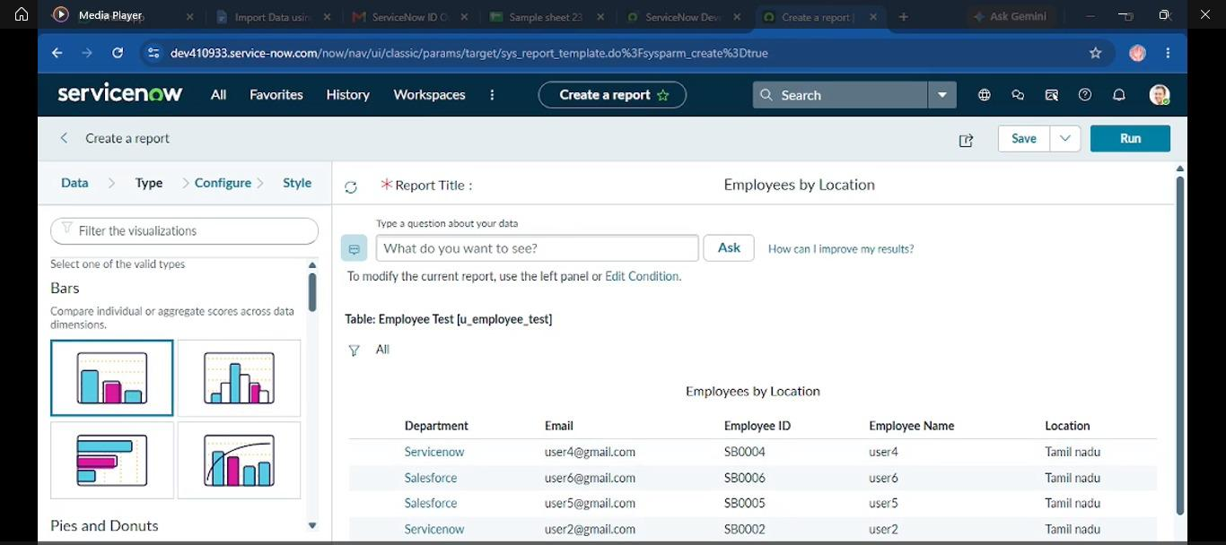

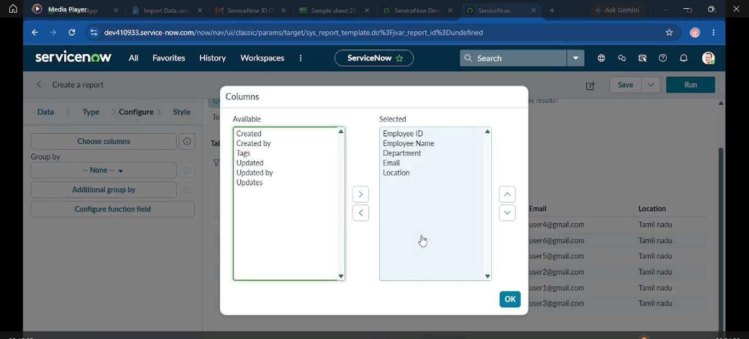

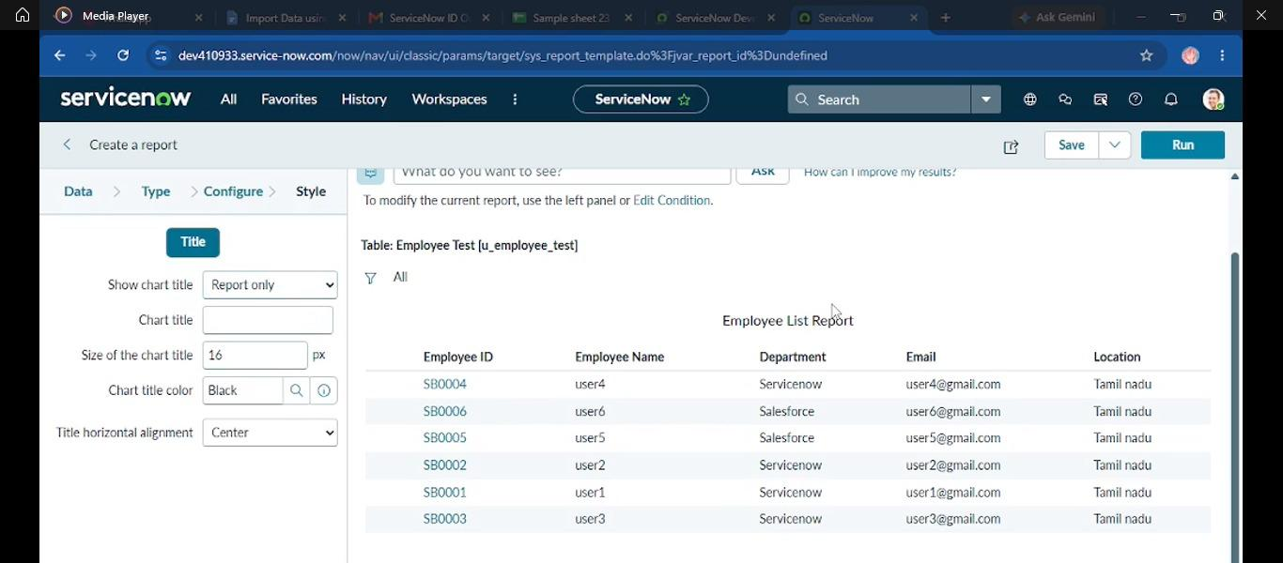
- Employee Analytics Dashboard

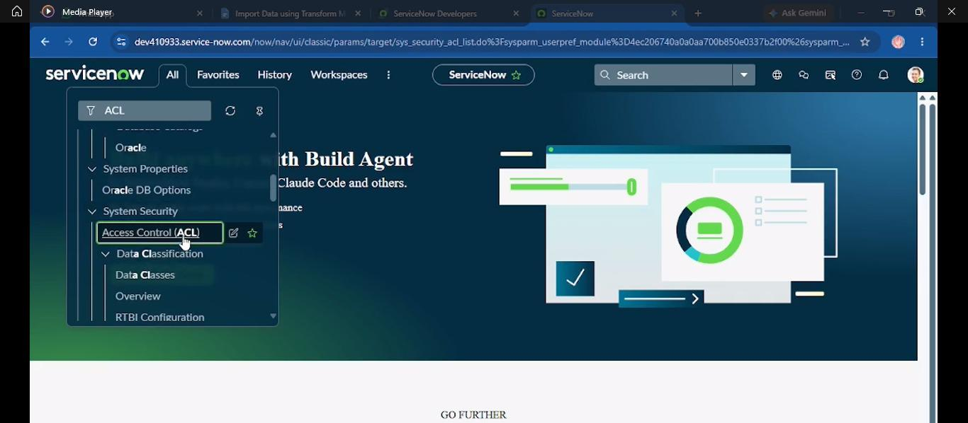

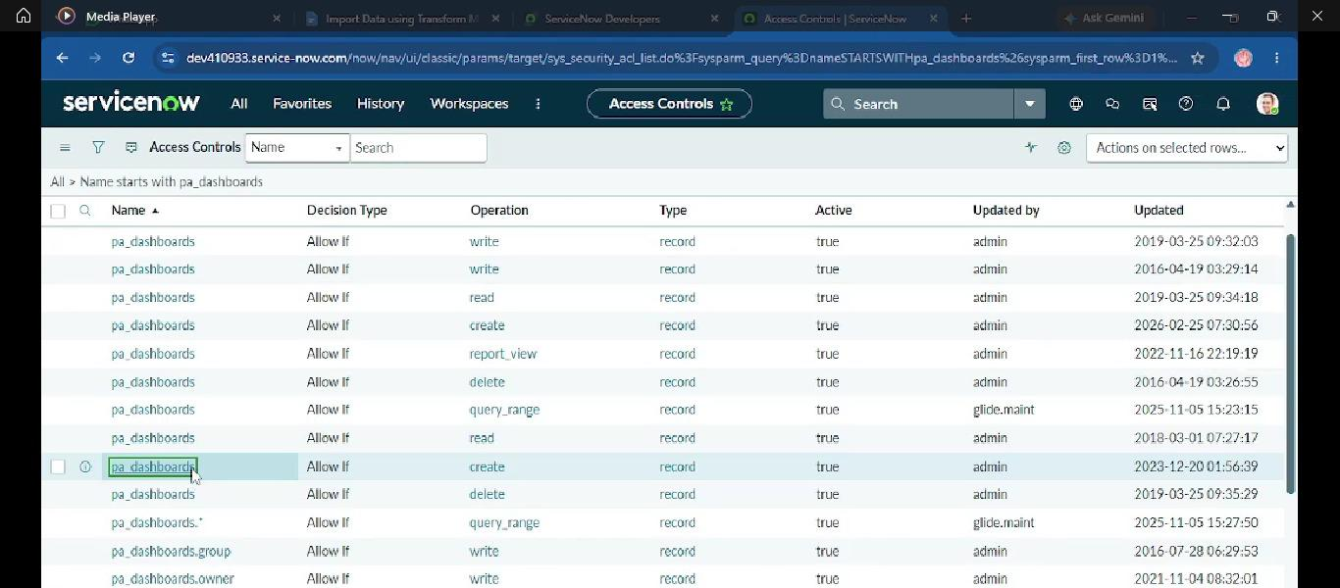

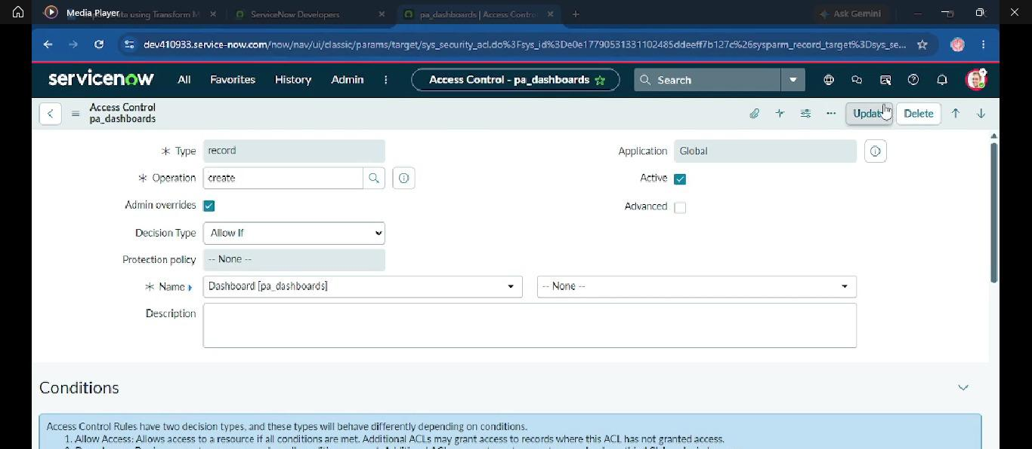

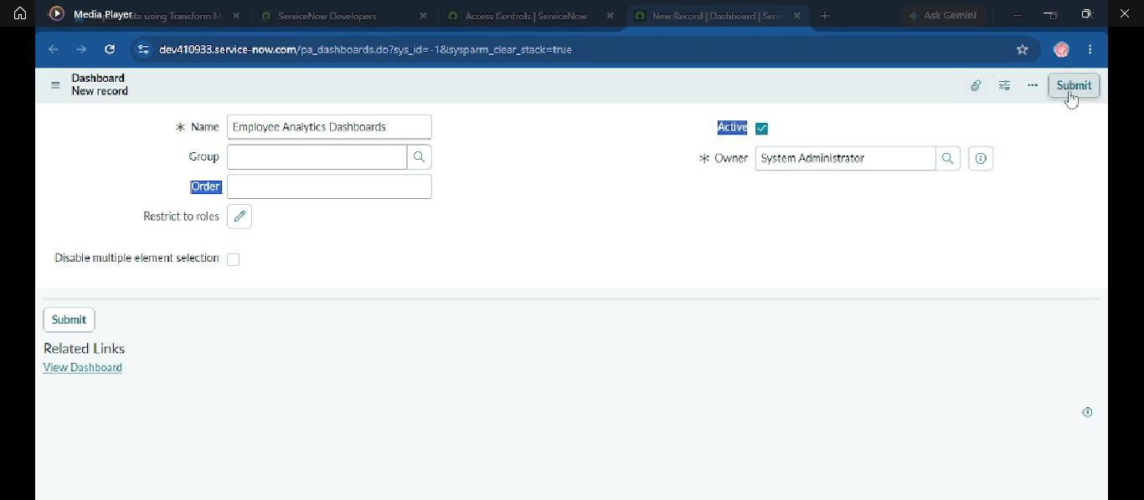

Add Reports to Dashboards

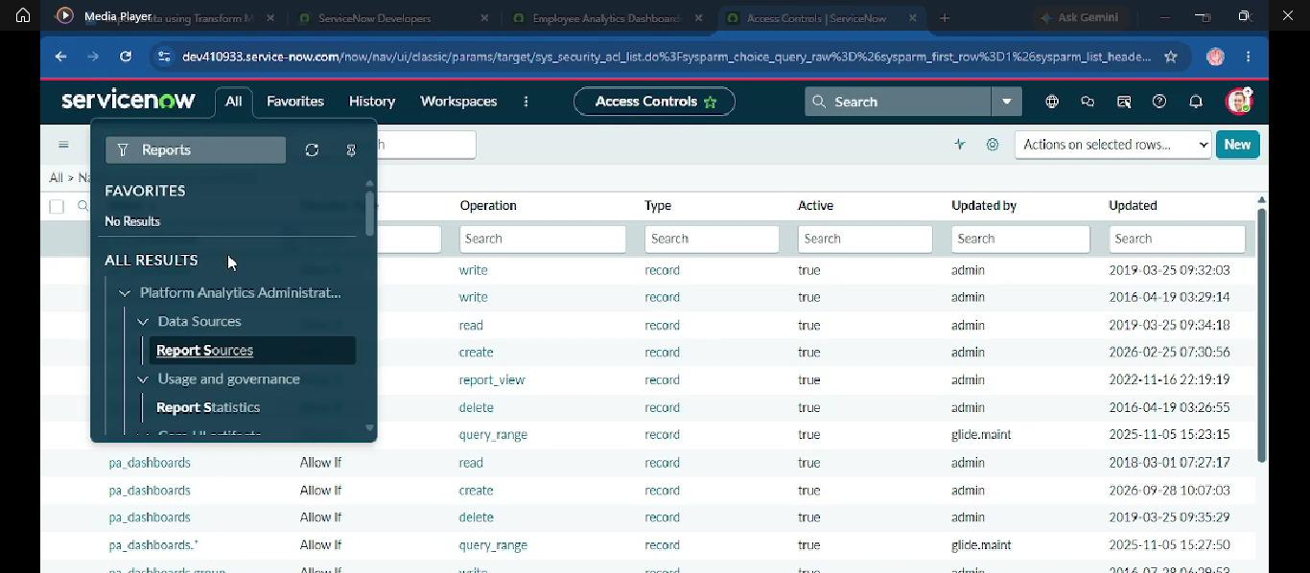

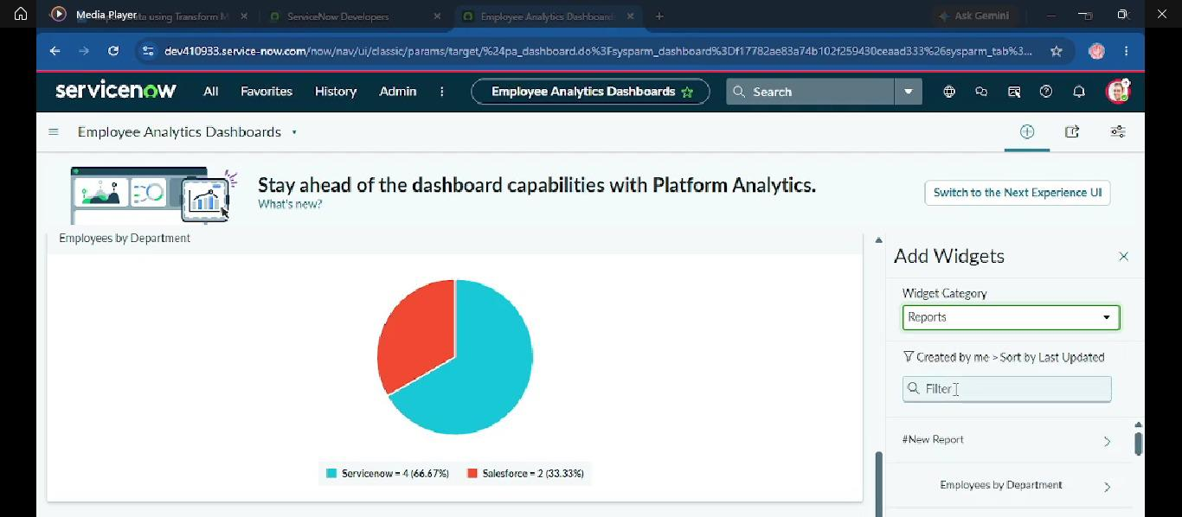

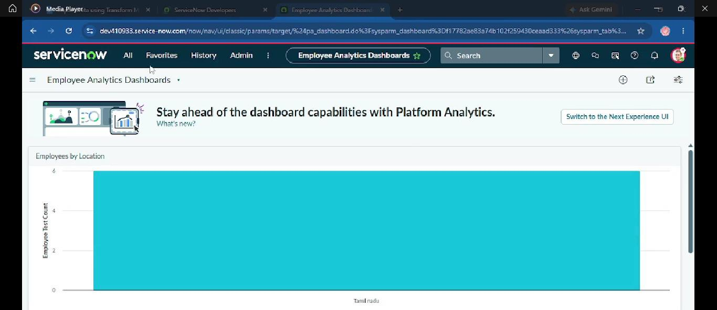

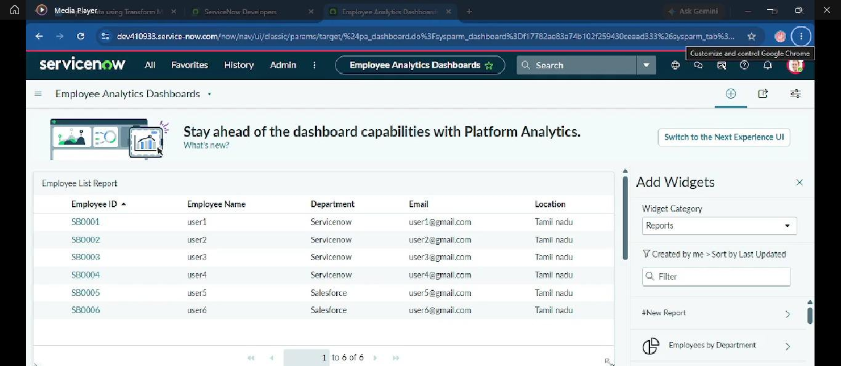

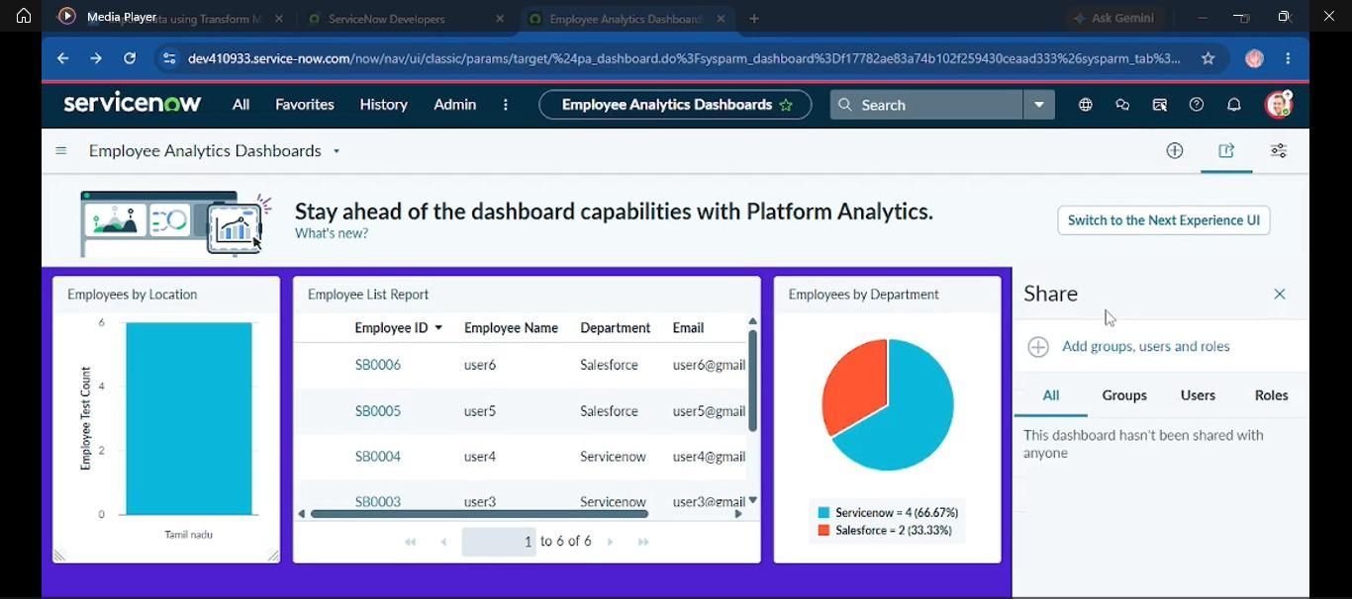

Complete Demo Flow
Spreadsheet → Load Data → Import Set → Transform Map → Field Mapping → Transform → Employee Test → Coalesce Testing → Reports → Dashboard

18. Known Issues
- Incorrect Field Mapping – Incorrect mappings can store data in the wrong target fields.
- Missing Values – Missing employee information may result in incomplete records or transformation problems.
- Duplicate Employee IDs – Incorrect IDs can affect Coalesce processing.
- Invalid Spreadsheet Data – Incorrect formats or invalid values may cause transformation errors.
- Permission Restrictions – Some ServiceNow functions require appropriate roles and permissions.
- Dashboard Access – Users without required permissions may not be able to view or modify dashboards.
- Large Spreadsheet Files – Large datasets may require additional processing time.

19. Future Enhancements
- Automated Data Import – Schedule regular employee data imports.
- Advanced Data Validation – Validate Employee ID, email, department, location and mandatory fields.
- Transform Scripts – Add advanced transformation logic and business rules.
- Automated Notifications – Notify administrators when imports succeed or fail.
- Enhanced Dashboard – Add total employees, new employees, updated employees, success/error counts and distribution widgets.
- External System Integration – Replace manual spreadsheets with automated HR-system integration.
- Improved Error Handling – Provide better mechanisms for identifying and reporting failed records.

20. Project Outcome
The project demonstrates an end-to-end employee data import and management process using ServiceNow. Employee data is prepared in Excel, loaded into an Import Set staging table, transformed into the Employee Test target table, validated, and analyzed through reports and a dashboard.
- Spreadsheet data is successfully loaded into ServiceNow.
- Import Set data is stored in a staging table.
- Transform Map transfers data to the Employee Test table.
- Source and target fields are mapped correctly.
- New employee records are inserted.
- Coalesce identifies existing employees.
- Existing records are updated instead of duplicated.
- Repeated records can be prevented from unnecessary insertion.
- Transform History validates transformation results.
- Reports provide employee data analysis.
- Dashboard provides a centralized view of reports.

21. Conclusion
This project successfully implements an employee data management solution using ServiceNow Import Sets and Transform Maps. It demonstrates how structured employee information can be transferred from an external Excel spreadsheet into ServiceNow in an efficient and controlled manner. The project also demonstrates field mapping, Coalesce-based duplicate prevention, data validation, reporting and dashboard creation. Overall, the solution provides a practical workflow for managing bulk employee data within the ServiceNow platform.

